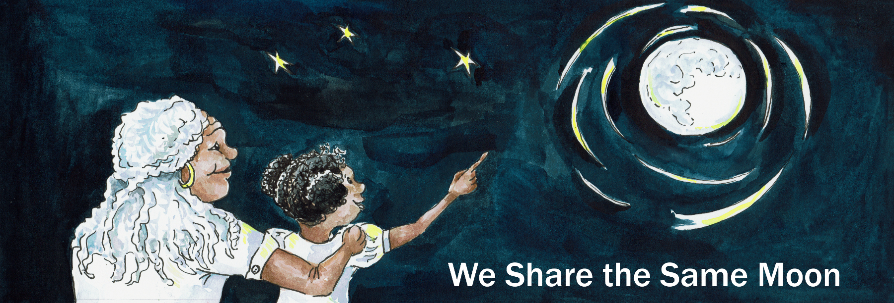

Suggested Age Range: 9 – 10 years
UK Primary Curriculum: Key Stage Two (upper)
Suggested UK Year Group: Year 5
UK Primary Curriculum Link: Earth and Space
Science Subject: Constellations
Science question: What are constellations? How are stars arranged in space?
Activity type: individual or pairs
Suggested linked story: How the Pleiades were created; How Fisher went to Skyland; Starlight; How Coyote made the Stars

Brief summary: Constellations are patterns of stars in the sky. While these patterns are extremely useful for learning your way around the sky, and for use in navigation on the Earth, these constellations are not physical groupings of stars. We see the patterns that we define as constellations because of the three-dimensional arrangement of stars in space.

Key concept: Constellations are groups of unrelated stars. The shapes we see are due to the location in space from which we view them.

The science story: Do you know what a pattern of stars is called? A pattern of stars is called a constellation. Constellations are groups of stars on the sky. Some constellations look like animals or people. Can you name any constellations that you know? Famous constellations include Orion (the hunter), Leo (the lion), Scorpio (the scorpion), Cassiopeia (the queen of ancient Ethiopia), and Crux (the southern cross). Many of these constellations were invented by the people of ancient Greece, almost two thousand years ago, but other countries have different shapes that they see in the sky. Why did the ancient people invent these constellations? In ancient times it was very important to know the positions of the stars and how the stars changed with the seasons, because this meant that you could navigate, travelling safely to explore new places and able to find your way home again. We find it easy to remember something when we hear it told as a story. Constellations look like patterns of stars on the sky, but stars are spread out like the trees in a forest: some stars are close to us, and others are much further away. Some stars are formed together at the same time, these are called clusters; other stars are formed at different times and much further apart, humans make patterns from these stars called constellations. The constellations that we see in the sky are unique to the Earth. From anywhere else in the Universe, the patterns of stars would look different, and we would see different shapes and constellations in the sky.

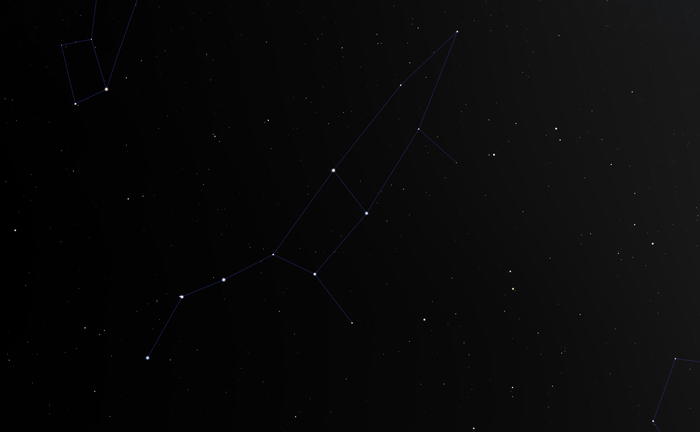
Above: a pattern of stars that make up a constellation on the sky. This pattern is known as the Plough, the Big Dipper, the Great Bear, or Fisher, depending on where you are in the world. Created using Stellarium (https://stellarium.org/).

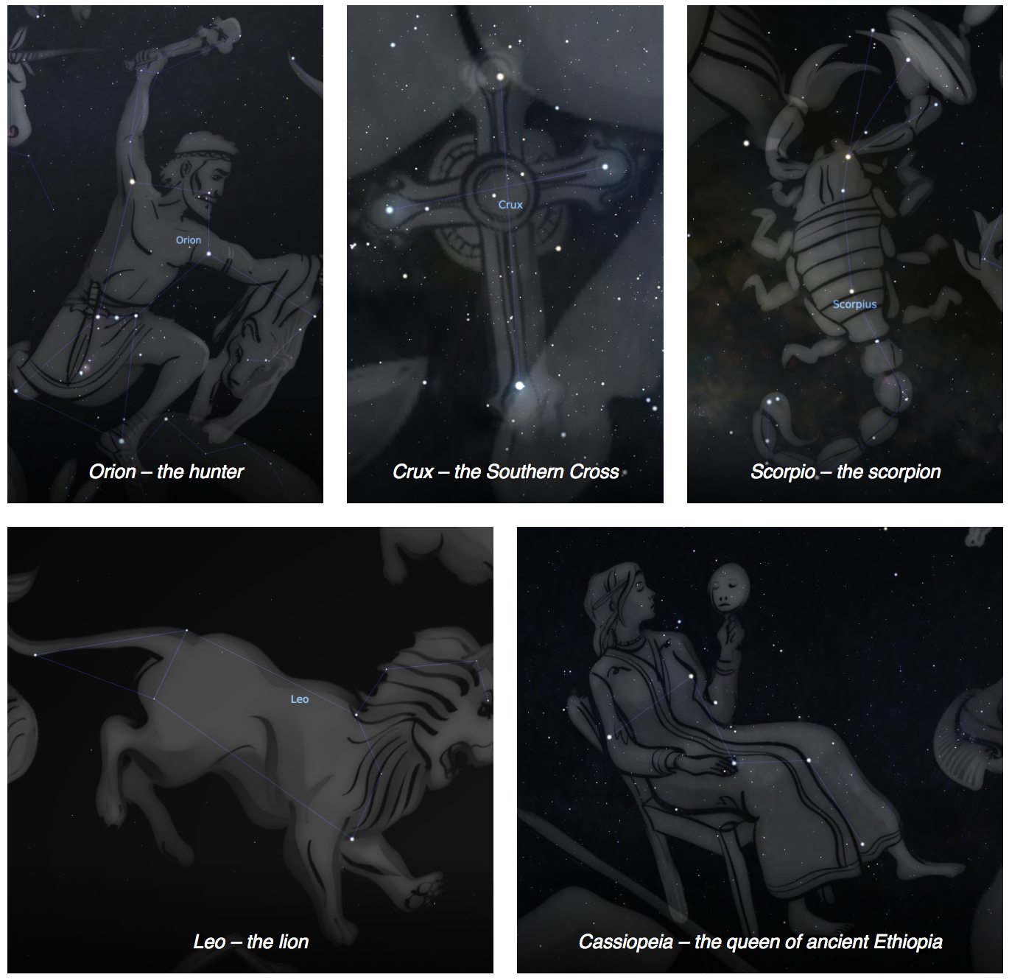
Above: images from the planetarium program Stellarium, showing the constellations referred to in the science story, above.
The science: The stars that you see when you look up at the night sky are very like our own Sun – giant nuclear reactors that shine with incredible power. Our galaxy, known as the Milky Way, is made up of one hundred thousand million stars (roughly), including our own Sun, arranged in a disk shape. Our Sun sits inside the Milky Way, roughly two thirds of the distance from the centre to the edge of the disk.

Some stars are bigger and brighter than the Sun, others are smaller and fainter than the Sun. For stars of a particular brightness, the closer to the Earth a star is, the brighter it appears on the sky. A nearby star that is intrinsically faint can appear brighter to us than a more distant star that is inherently much brighter. This idea can be illustrated using distant streetlights and a nearby torch – even though the torch is actually fainter than the streetlight, it can be used to read a book up close even when not enough light is reaching you from the distant streetlight.

Some stars formed together at the same time as clusters. These are natural groups of stars. Constellations are made of stars that formed in different locations at various different times – these groupings are entirely artificial. Some prominent patterns of stars are not true constellations but form just part of a much larger constellation; these prominent patterns are known as “asterisms”. Famous asterisms are the Big Dipper which is actually the hindquarters and tail of the constellation of the Great Bear, Ursa Major, and the “W” shape of Cassiopeia. The constellation we will use in this activity is the Fisher constellation, similar to the Great Bear on the sky, but comes from the sky lore of the First Nations of America.

While we are used to thinking of constellations as patterns of stars on the sky, in reality they are made up of (usually) widely separated stars that are physically unrelated to each other. This activity illustrates this concept using a simple table-top model that the students can construct and explore for themselves.

A useful analogy is with trees in a managed forest where they have been planted in rows. The rows look obvious from some angles, but not others.

The activity:
In this activity, students use simple materials to construct their own model of the Fisher constellation, as defined by the First Nations of America. The same stars make up Ursa Major, the great bear, seen in modern star atlases. The model illustrates how a constellation only looks like Fisher when viewed from a particular viewpoint. The students can explore the model themselves and should be encouraged to see that the same arrangement of stars will look very different when observed from any other angle.

Props required:
- Printed copy of the Fisher constellation (see below)
- Table of stars and their properties (see below)
- A4 piece of card
- Glue
- Tape
- Thread
- Foil
- Ruler
- Needles or scissors

- Take the picture of the Fisher constellation and carefully glue it to your cardboard sheet. Make sure you can still see the constellation!
- Use the needle or a pair of scissors to carefully make holes through the card at the position of each star in the image. Make sure your hole goes all the way through the card.
- Carefully tear your foil into squares roughly 5cm by 5cm. You will need eleven pieces of foil.
- Cut eleven pieces of thread, each piece should be 25cm in length.
- Tape a piece of thread to the centre of a piece of foil.
- Crumple the foil into a ball around the end of the thread. Make the ball as small as you can! This is your first star.
- Repeat steps 5 and 6 for the other stars. You should now have eleven stars. These stars will hang from your card to make your constellation mobile.
- Take one of your stars and carefully push the free end of the thread through the hole marked “Alkaid” in your picture of Fisher.
- Find the star Alkaid in the table of stars. The table tells you how long the thread needs to be for your mobile to look right. Use your ruler to measure the thread so that your star hangs at the right distance below your card. For Alkaid, the star should hang 16cm below the card.
- Tape the excess string to the back of the card.
- Repeat steps 8 to 10 for the other stars. Note that for star 6, Alkaphrah, the length is 0cm. For this star, push the thread through the card as with the other stars, but pull it all the way through so that the star is touching the card.
- When you have all of your stars taped in place, hold up your mobile over your head. Look carefully at your constellation – can you see the shape of Fisher?
- Look at your mobile from other positions and angles – do the stars look like the Fisher constellation if you look at them from the side? Are there any other ways of looking at the mobile that make the same constellation?
- You may have noticed that there is a star missing! One of Fisher’s feet, 30 Uma, is not included in our model. This is because it is much further away from the Earth than the other stars. If we were to include 30 Uma in our model, we would have to make all of the threads longer by 51cm!

Extension: A larger version can be constructed using (for example) small lights and string hanging from the roof or other elevate structure. Students could design their own constellation “installation” for the classroom, using mathematics to determine the lengths of string needed and the locations of the positions of the strings.

The idea of constellations could be further explored through creative arts by encouraging the students to design their own constellations around real patterns of stars, coming up with their own stories for their constellations, and creating their own artistic representation of it.

Common misconceptions:
- Constellations are often thought to be physical associations of stars, when in reality they are entirely artificial and the shapes we see are purely line-of-sight effects.

Curriculum links:
- Maths KS2 – number – counting and measuring, and using negative numbers
- Maths KS2 – geometry – position and direction – identify, describe and represent the position of a shape following a reflection or translation, using the appropriate language, and know that the shape has not changed
- Maths KS2 – geometry – properties of shapes – identifying and using angles (as lines of sight to view the mobile)
- Maths KS2 – measurement – using different measuring systems (comparison of light years to centimetres)
- Geography – America – understanding how the first Americans lived prior to the invasion of Columbus (navigation)
- History – America – Fisher (also known as the Big Dipper) was used by slaves to make their way to freedom e.g. http://www.northern-stars.com/Follow_theDrinking_Gourd.pdf

Linked activities:
https://astroedu.iau.org/en/activities/1613/make-a-star-lantern/
Make a star lantern – astroEDU
Can be used to introduce the idea of constellations where this is less familiar.
https://astroedu.iau.org/en/activities/1607/what-is-a-constellation/
Create a model of Orion – astroEDU
A longer, more involved version of this activity.
https://www.amnh.org/explore/ology/astronomy/build-the-big-dipper2
Similar activity from the American Museum of Natural History.

Copyright: Megan Argo 2019

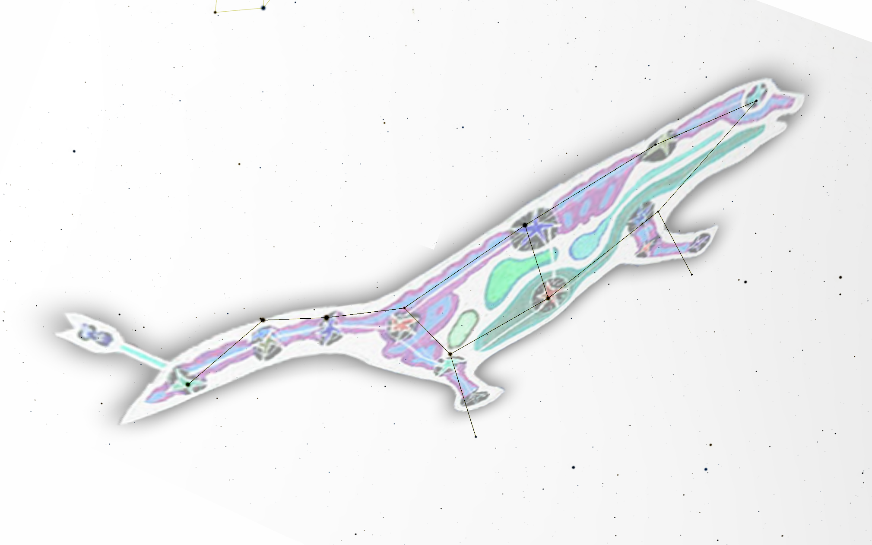
Alkaid
Mizar
Alioth
Megrez
Phad
Alkaphrah
Dubhe
Merak
29 UMa
30 UMa
23 UMa
Muscida

Number | Star | Distance from Earth | Thread length
1 | Alkaid | 104 light years | 16 cm
2 | Mizar | 78 light years | 21 cm
3 | Alioth | 83 light years | 20 cm
4 | Megrez | 81 light years | 21 cm
5 | Phad | 83 light years | 20 cm
6 | Alkaphrah | 184 light years | 0 cm
7 | Merak | 80 light years | 21 cm
8 | Dubhe | 124 light years | 12 cm
9 | Muscida | 179 light years | 1 cm
10 | 23 Uma | 78 light years | 21 cm
11 | 29 UMa | 116 light years | 14 cm

Below is a table of the stars and the numbers that you will need to construct your constellation mobile.

